2026 QUARTERLY REPORT
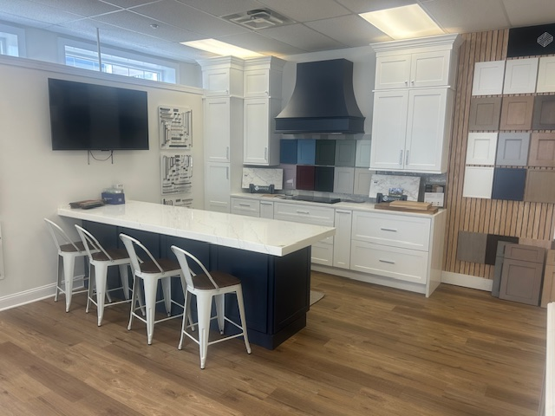

July 1, 2026

STONE CRAFTERS LLC
Authored by: Matt Zuccarello

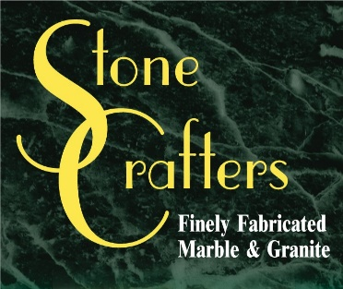

Company Spotlight – The Cabinet Company
Owner: Sean Collins
Designer: Idalis Santana
Background: Family-owned business for 8 years originally located in Avalon and then moved to Sea Isle, NJ, has two children and a wife and lives in Upper Township, went to college at Stockton University and majored in Marketing, also owns The Range in Cape May Court House
Hobbies: Sean enjoys collecting baseball cards, watching sports, and real estate
Highlights: Voted Most Likely to Succeed in High School and best cabinet company in Sea Isle 2 years in a row
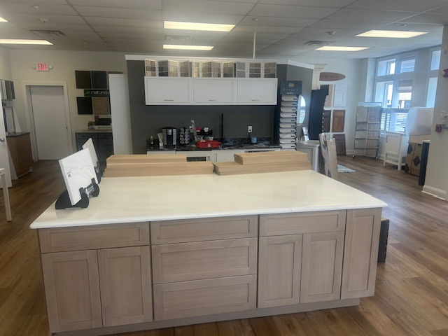
Sean Collins started The Cabinet Company over 8 years ago and currently employs 3 people. He ran Gem Pizza for 30 years previously and started while he was in college at Stockton University. He went to Overbrook HS and played basketball there and attended the same time as former NFL player Ron Dayne. He has invested in real estate properties in the past and owns The Range, which opened 3 years ago, in Cape May Court House which features miniature golf, batting cages, a golf range, ice cream shop and now a section for baseball cards. They specialize in kitchen design and full home renovations in the Sea Isle, Avalon, Wildwood and Stone Harbor area. You can check out their beautiful showroom right off the main avenue in Sea Isle and select from several different cabinet lines along with making your countertop selections.
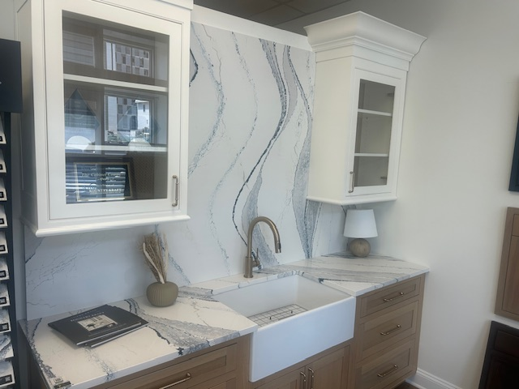

Latest Industry Trends
With several NKBA events in the books, this year’s trends continue to shift towards rich, dark wood finishes, “whisper quiet” natural stone slabs, and other moves towards making the kitchen a personalized and intentional living space. Deep and moody tones, disappearing appliances and slab-front cabinetry continue to set the tone for the kitchen space while in the bathroom, checkerboard patterns, furniture-style vanities, integrated showers, and tactile materials continue to pave the way.

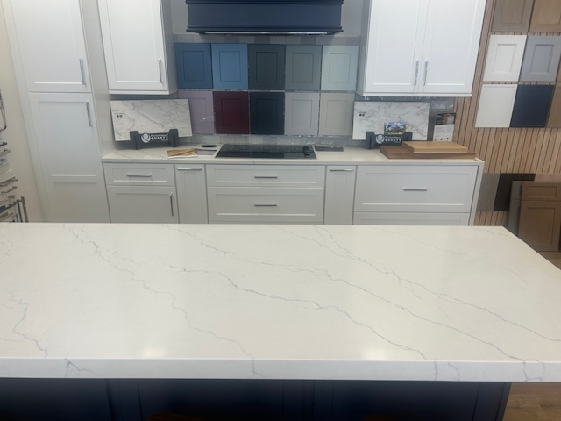

Suggestions for Future Newsletters and Summary

As 2026 continues into the spring season, there will be more renovations and construction projects that we will be involved in. If you have a client or exciting kitchen that you would like to do a product spotlight on in a future edition, on social media, or our website, please reach out to me so we can get some pictures and copy to publish to highlight this. If there is anything that you suggest for our next newsletter, please reach out to me.

Matt Zuccarello

Stone Crafters

