2025 QUARTERLY REPORT
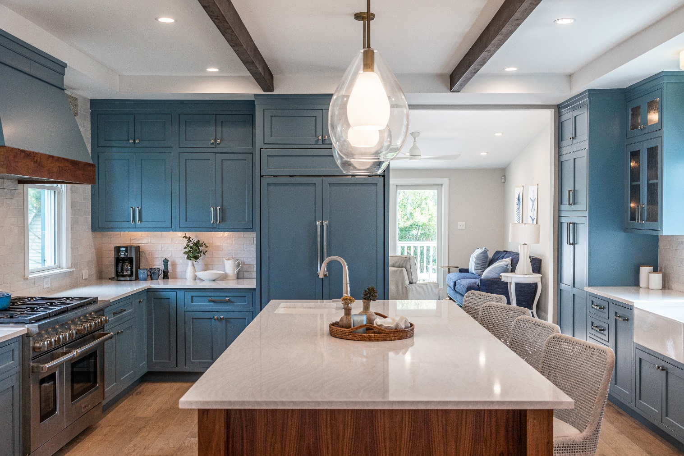

January 8, 2024

STONE CRAFTERS LLC
Authored by: Matt Zuccarello

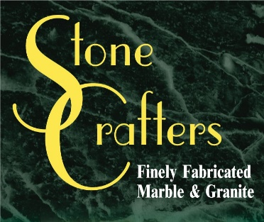

Company Spotlight – O’Connor Home Design

Background: 20 years of experience in the industry and owned company for 6 years
College: Graduated with a Bachelor’s Degree in Interior Design from Drexel University in PA
Hobbies include kickboxing, going to the beach, and traveling with her son, Logan
Highlights: In 2024, won Best of Jersey Shore in the furniture store/home furnishings and interior designs categories
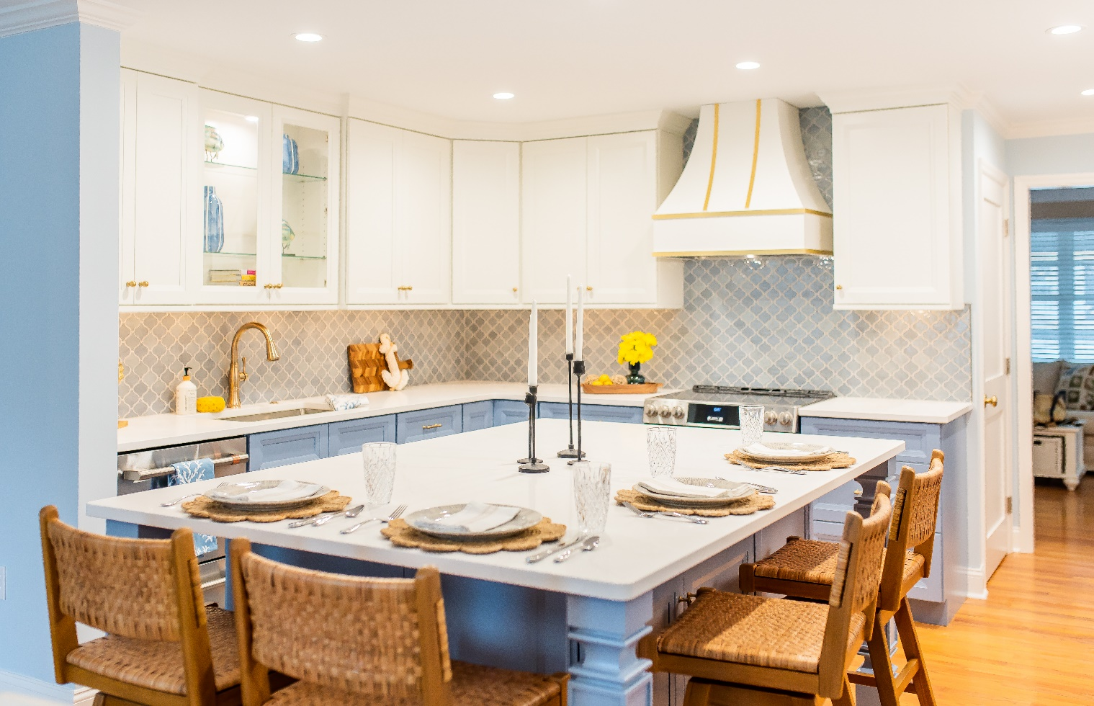
Jennifer O’Connor is the owner of this kitchen and bath showroom located in Cape May, across from the C-View Inn. It is also an interior design showroom. She runs an all-women company of four and their focus is on homes from Cape May to Brigantine, along the Jersey shore coastline. She has been in business for just over 6 years now and been involved in the industry for 21 years. By the summer of 2025, there will be several beachfront properties in Brigantine that will be completed and the kitchens will be done with high end material for their countertops. The pictures are from houses we fabricated countertops for her company in Ocean City and Cape May using various quartz materials.
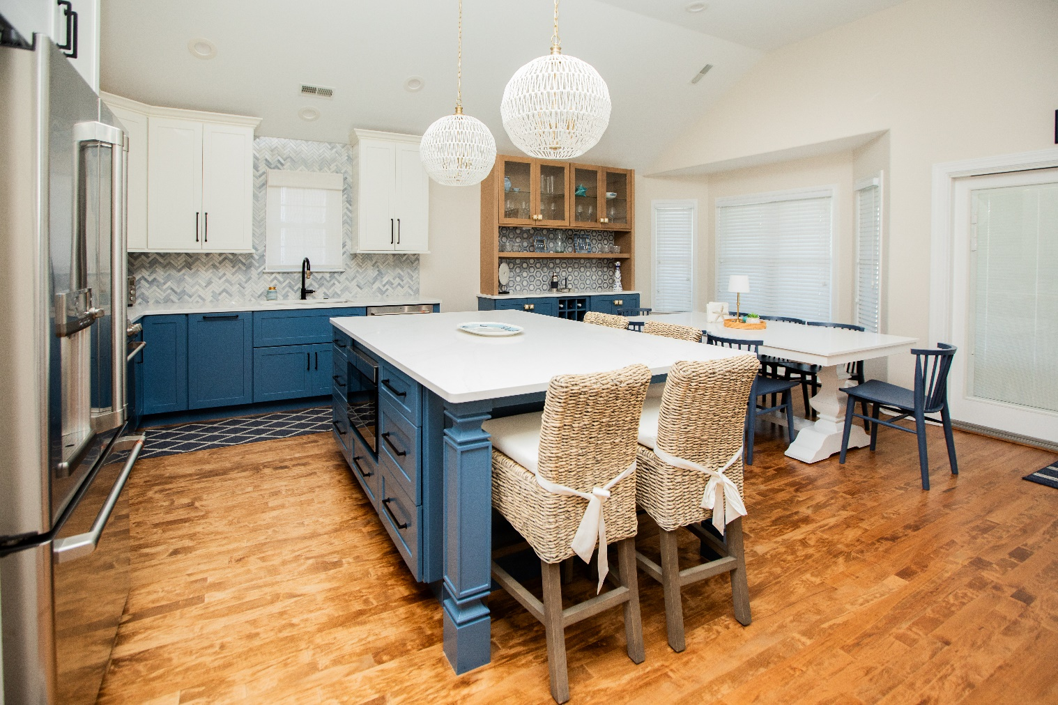

Latest Industry Trends

News from the field

Some of the latest trends when it comes to bathrooms for 2025 include spa-like sanctuaries, black accents, wet rooms and organic materials and natural textures. This is according to research done by House Beautiful. According to Decorilla, some of the hottest trends in the kitchen world will include sustainable materials, mid-century modern style, eco-friendly kitchen appliances, bigger pantries, concealed kitchens and multipurpose kitchen islands are among the most popular. Kitchens are becoming more than a place to just create meals, they are being transformed into multifunctional spaces that reflect personal style, sustainability, and advanced technology.
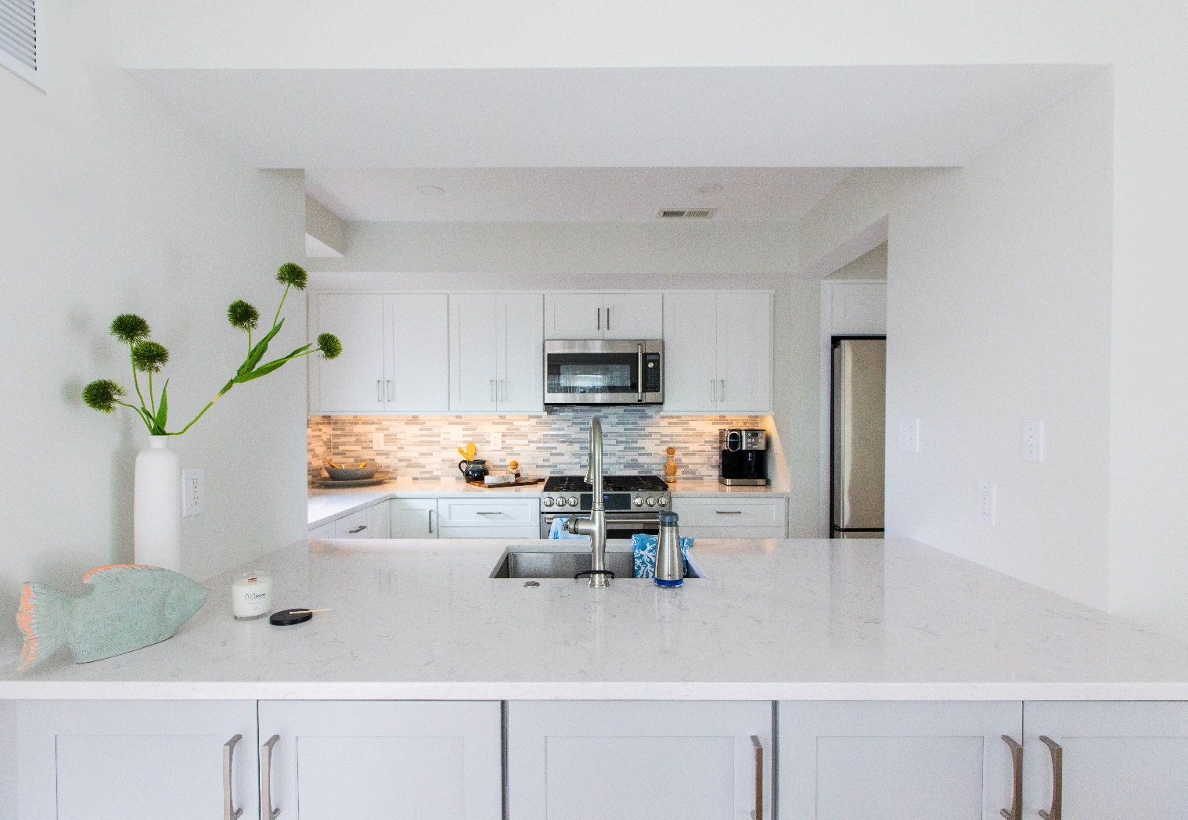

Suggestions for Future Newsletters and Summary

As 2025 continues on, there will be new renovations and construction projects that we will be involved in. If you have a client or exciting kitchen that you would like to do a product spotlight on in a future edition, on social media, or our website, please reach out to me so we can get some pictures to publish and highlight this. Any new ideas that you would like a focus on in our next newsletter, please reach out to me.

Happy designing and remodeling. Here’s to a successful and creative 2025!!

Matt Zuccarello

Stone Crafters

