2024 QUARTERLY REPORT
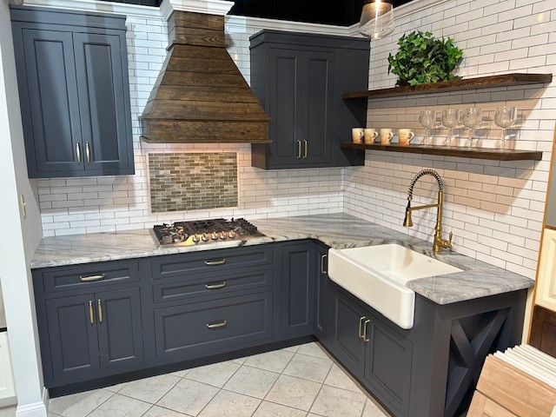

October 23, 2024

STONE CRAFTERS LLC
Authored by: Matt Zuccarello

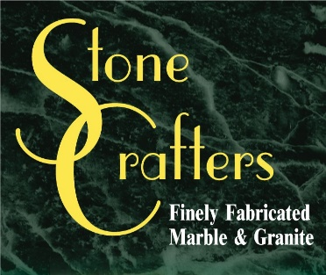

Company Spotlight – Quality Home Center
Owner: Bret Coupland
Background: Been in business since 1997
College: Graduated from Lehigh University as a Finance major
Hobbies include fishing
Highlights: Tim McCline won the Presidents Award from Candelight Cabinetry the last 5 years
Danielle Wakefield won the Rising Star Award from Candelight
Featured in the NY Times for continued success and growth, despite Home Depot and Lowes opening new locations in close proximity
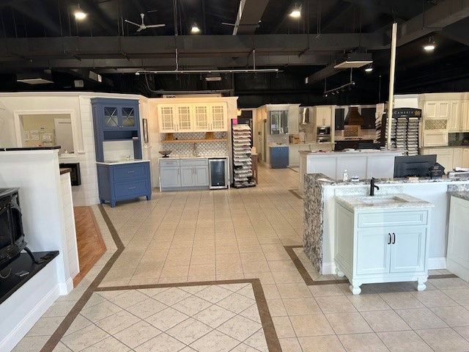
Bret Coupland is the Owner of this kitchen and bath company located in Cape May Court House. They have been working with Stone Crafters for 12 years now. He has 3 children and lives in Egg Harbor Township. Bret actively is involved in his kids’ sports schedule, coaching soccer as well in his free time. His company consists of 15 people, with 3 designers and 3 teams of installers. He started out in corporate finance for 5 years after college in the Philadelphia area and when the opportunity arose to move to the shore, he couldn’t pass this up. With the new location, came some other changes. They transitioned from a neighborhood hardware store to focus on kitchens, baths, and fireplaces. He was also looking to be involved more with the design process and customers when it came to home renovation. His showroom is right off of the parkway in southern NJ. If you are in the area, stop in for a visit.
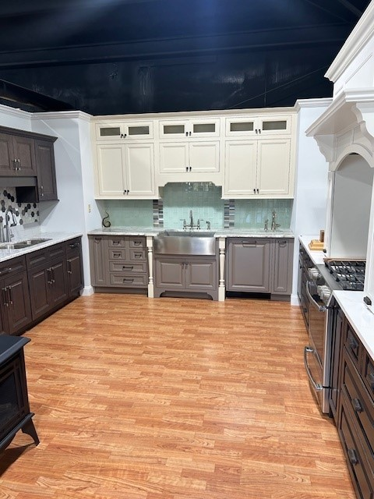

Latest Industry Trends

News from the field

The 2024 K&B revenues are projected to be $173 billion, a decrease in 3% compared to last year at the same time. New construction spend is projected to decline 4% and remodeling spending forecast is expected to be down 2%.

With KBIS around the corner, here are some of the kitchen trends for 2025. They include concealed kitchens, bigger pantries, multipurpose kitchen islands, natural light and views and personalized spaces.

Finally, some of the top cabinet color trends for 2025 include a trending forest green, soft blue to create a calming kitchen, replacing black with dark charcoal, adding elegance with the darkest of blues, add drama with emerald green, picking stains over paint colors and switching gray cabinets for sage green.

Suggestions for Future Newsletters and Summary

As 2024 continues on and we get closer to 2025, there will be new renovations and construction projects that we will be involved in. If you have a client or exciting kitchen that you would like to do a product spotlight on in a future edition, on social media, or our website, please reach out to me so we can get some pictures and copy to publish to highlight this. If there is anything that you suggest for our next newsletter, please reach out to me.

Matt Zuccarello

Stone Crafters

