2025 QUARTERLY REPORT
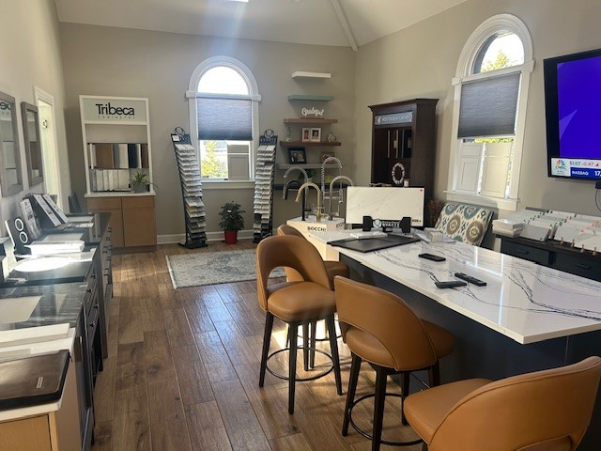

March 19, 2025

STONE CRAFTERS LLC
Authored by: Matt Zuccarello

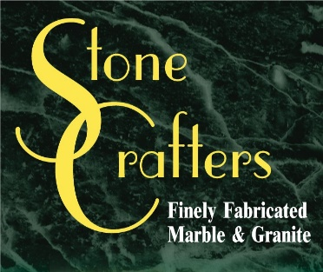

Company Spotlight – South Shore Cabinetry
Owner: Derek Southard
Background: Been in business since 2022, also owns Fresh Look Construction
College: Graduated from Champlain College as a Communications major
Played Division I basketball for Juco school
Hobbies Include coaching basketball and baseball for his boys ages 10 and 13
Highlights: Won Best of 2023 Marmora for Home Improvement Store
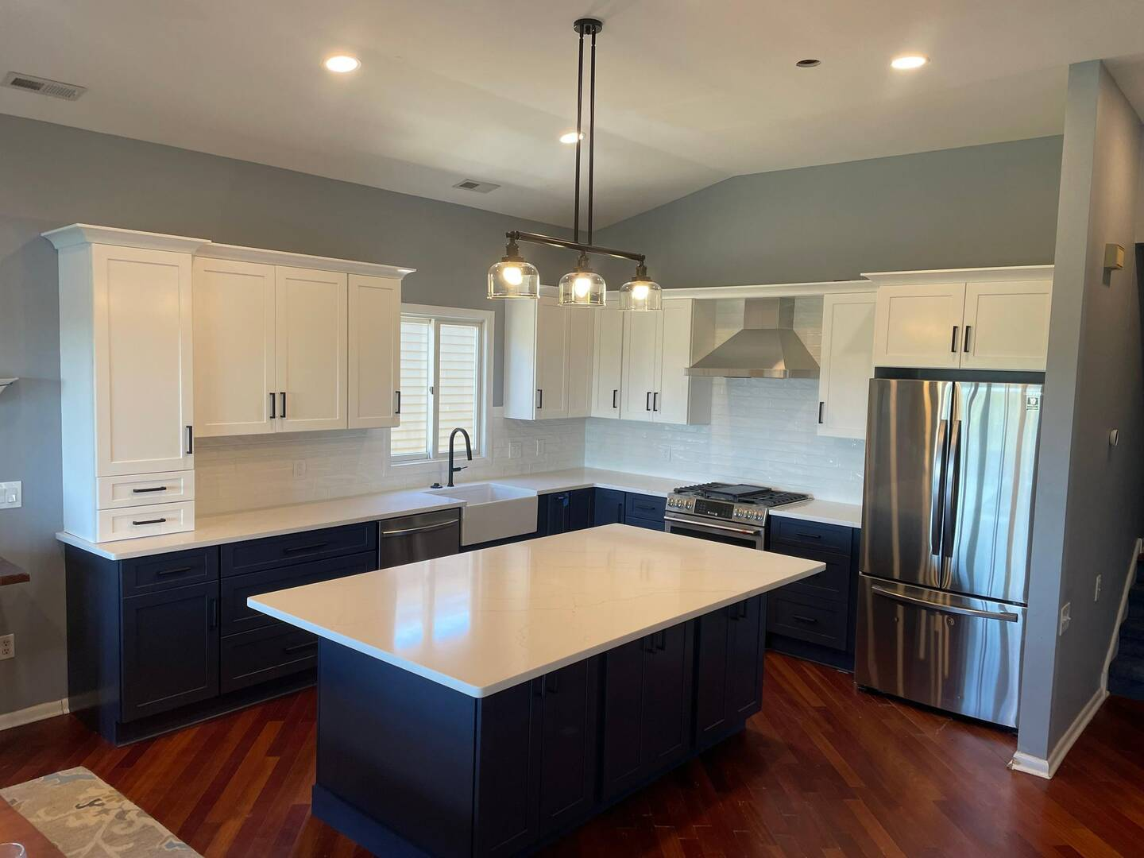
Derek Southard is the Owner of this kitchen and bath company and construction company located in Ocean View. He has been in business since 2022 and is relatively new to the industry. Fresh Look Construction has been in business for about 5 years now. He is setting new standards in the industry with a personalized approach focused on Cape May County. He services Ocean City, Stone Harbor, Sea Isle, Wildwood, Avalon and Somers Point. Derek is retired military from the Air Force who served our country for many years. His focus now is on renovations. He was born in Vermont and moved to Ocean View in 2018. He employs 10 people currently and takes pride in everything and uses his code of ethics from the Air Force with his customers. From design to install, his attention to detail for residential homes is top notch and he finds it rewarding when jobs are remodeled and completed. His latest showroom is out of his home in Ocean View and adds a personalized touch that makes the client feel at home, literally.
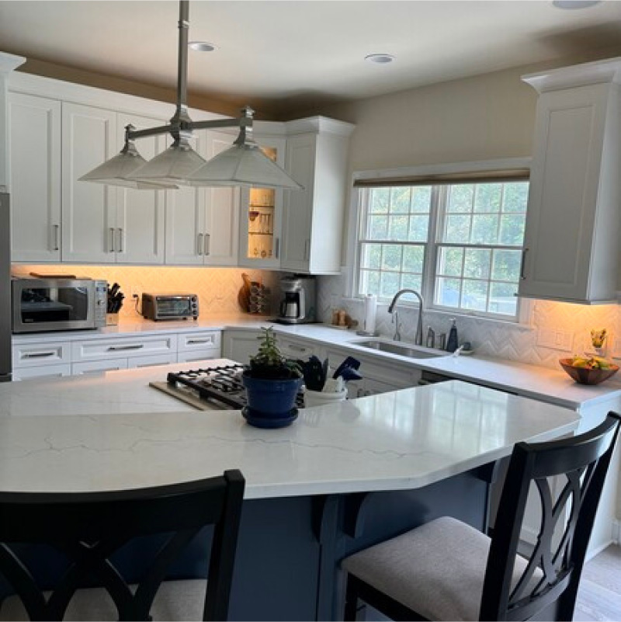

Latest Industry Trends

News from the field
KBIS took place at the end of February, with over 43,000 registered attendees with nearly 700 exhibitors. It was considered one of the largest in show history and was co-located with The International Builders’ Show (IBS) and creating Design and Construction Week (DCW). Attendees explored the latest kitchen and bath design trends.

Some highlights according to Galerie Magazine included backlit quartz fireplaces to Frank Lloyd Wright inspired faucets and many of the major brands this year did not disappoint. Kohler took home the coveted Best of Show award for the third year running along with spectacular booths and new offerings from Monogram, Neolith, Brizo, Artistic Tile, Cambria, True Residential, SKS and Café.

The 2026 show will be relocated to the Orange County Convention Center in Orlando, FL. It will also co-locate with the International Builders’ Show.

Silicosis and Tariffs – What the future holds?

Silicosis continues to be a subject that comes up from time to time and our shop has past all safety inspections in regards to the regulatory levels and we wet cut all of our materials. This will have no impact on the end user when the countertops are installed.

In regards to tariffs, we haven’t seen any impact in regards to the cost of materials as of yet but it has impacted the lumber pricing, by around a 20% increase from what I have been told. We hope this is just a short-term impact but cannot predict what the future holds.

Suggestions for Future Newsletters and Summary

As 2025 continues on and we get closer to the summer, there will be more renovations and construction projects that we will be involved in. If you have a client or exciting kitchen that you would like to do a product spotlight on in a future edition, on social media, or our website, please reach out to me so we can get some pictures and copy to publish to highlight this. If there is anything that you suggest for our next newsletter, please reach out to me.

Matt Zuccarello

Stone Crafters

