2026 QUARTERLY REPORT
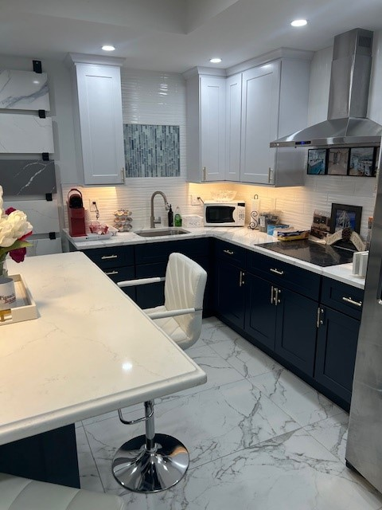

December 3, 2025

STONE CRAFTERS LLC
Authored by: Matt Zuccarello

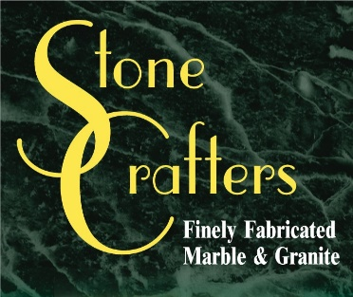

Company Spotlight – Pinnacle Building & Contracting
Owner: John Nickels
Background: Family-owned business for over 30 years located in Wildwood, NJ, John was born and raised in Wildwood
Hobbies: Include watching horse racing and football
Highlights: Best of Cape May Court House in 2021 recognition, highest recommendation and customer satisfaction for the last several years by customers in Cape May County. Also featured in House & Home magazine in 2013 highlighting a historical home renovation in Cape May.
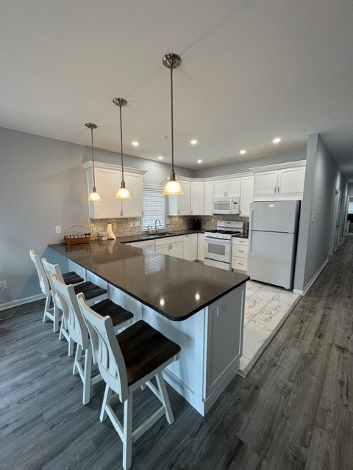
When John Nickels stopped working as General Manager for his family’s business, Nickels Midway Pier and Castle Dracula, he decided to get into building different things. This was a big transition as the boardwalk games and biggest landmark in the tri-state area, Castle Dracula were now a thing of the past. He started out as a troubleshooter for Home Depot for 5 years and then moved his passion to building homes. After several years in 2006, he decided to shift gears and got into remodeling and additions as well!! Born and raised in Wildwood, he stays true to his roots and has built up his business in town and has 4 children and 13 grandchildren currently. He is recognized around town and supports the local businesses as well. In 2013, he was featured in House & Home magazine for a historical home renovation he completed in Cape May. He services all of Cape May and Atlantic County primarily.
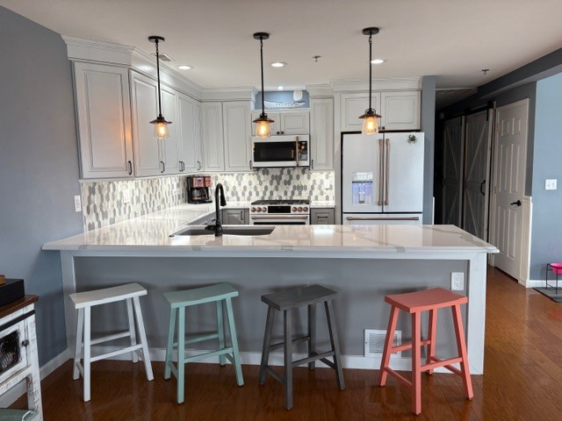

Latest Industry Trends
The latest kitchen and bathroom trends for 2026 will focus on personalized, multi-functional spaces with an emphasis on natural materials, organic shapes, and subtle, integrated technology. Some of the styles that will be popular included minimalist and transitional, while kitchen footprints are expected to grow as they become more central to home life. They will incorporate features like home offices and mudrooms.

In regards to bathroom trends, wellness focus, increased space and storage, integrated technology and dark and natural vanities are expected throughout 2026.

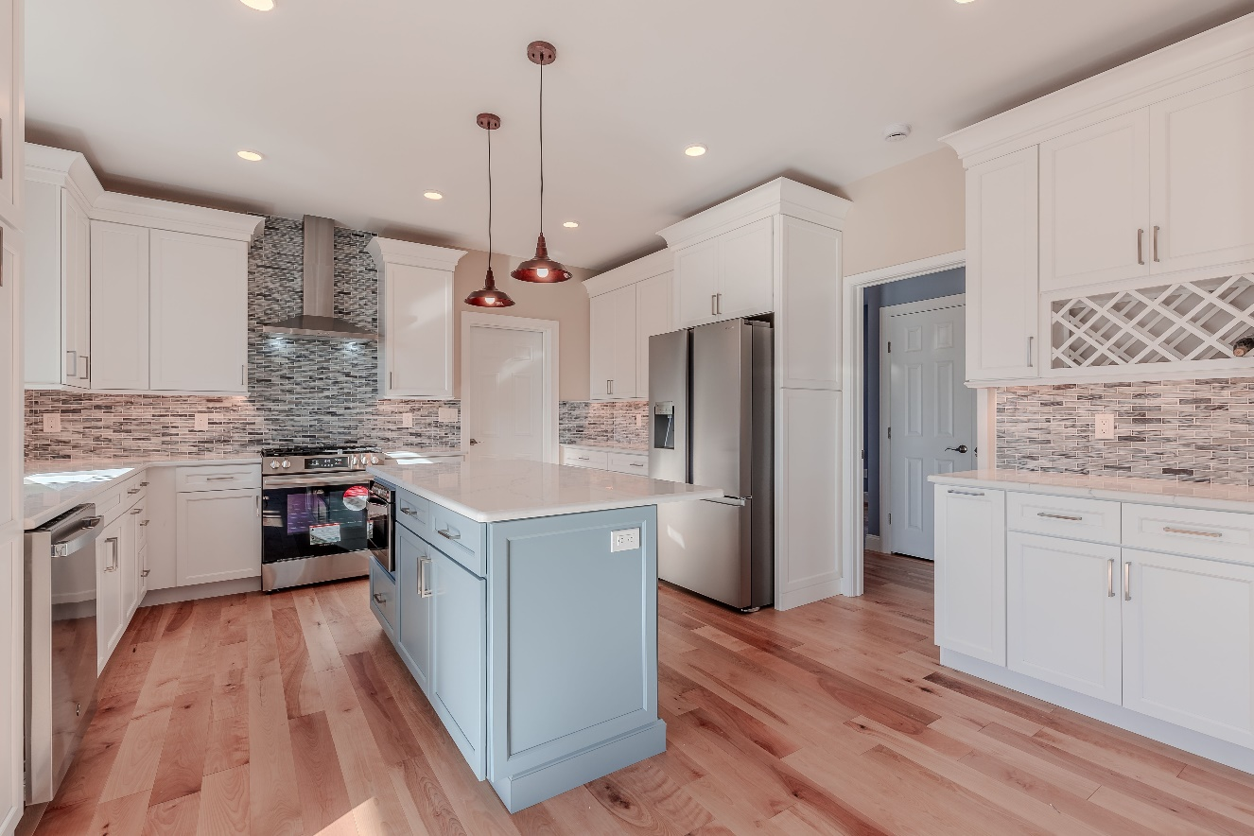

Suggestions for Future Newsletters and Summary

As 2026 starts and the holiday season behind us, there will be more renovations and construction projects that we will be involved in. If you have a client or exciting kitchen that you would like to do a product spotlight on in a future edition, on social media, or our website, please reach out to me so we can get some pictures and copy to publish to highlight this. If there is anything that you suggest for our next newsletter, please reach out to me.

Matt Zuccarello

Stone Crafters

