2026 QUARTERLY REPORT
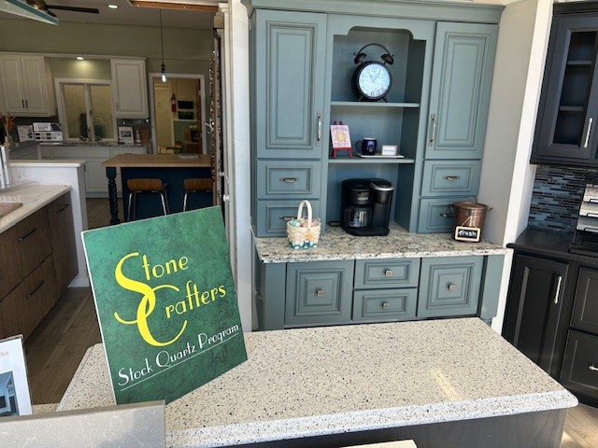

April 1, 2025

STONE CRAFTERS LLC
Authored by: Matt Zuccarello

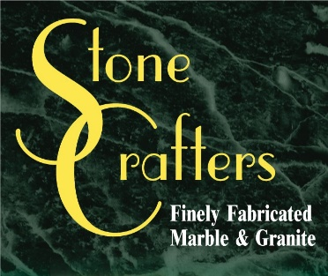

Company Spotlight – Shoemaker Lumber Kitchen & Bath
Owners: Janet Young & Lynn Tarves
Designers: Patty Ablett and Dan DeGaetano
Background: Family-owned business for over 124 years located in Ocean City, NJ, originally called C.H. Shoemaker Lumber
Hobbies: Patty enjoys kayaking, hiking, and tennis
Dan enjoys music, concerts, aquariums, and is into carpentry
Highlights: 2025 Silver award recipient of Press of Atlantic City Best of the Press (Best Kitchen store), and 2024 bronze award winner of the same category, Medallion Cabinetry outstanding performance award for multiple years since 2005
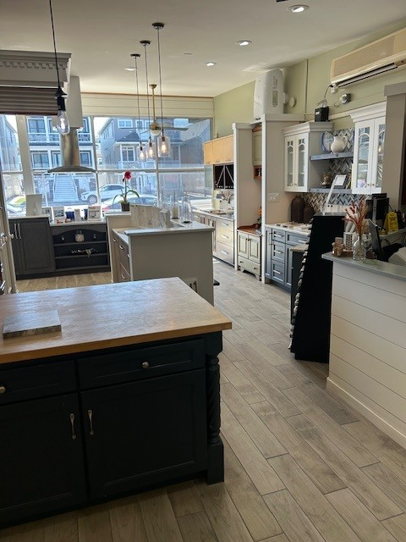
Patty Ablett has been working for Shoemaker Lumber for 40 years now. She started off in sales and transitioned into the Kitchen and Bath Design Manager. The company employs around 30 employees, and her other designer is Dan DeGaetano. He has been working with the company for 5 years and has been in the industry for around 23 years now. They serve mainly the Ocean City area and deal with contractors and residential homeowners. The company was originally started in 1902 in the same area and was originally named C.H. Shoemaker Lumber. They focus on semi-custom cabinetry design along with kitchen and bathroom design. They have received many awards over the years from outstanding performance for several years through Medallion Cabinetry to most recently the silver award for best kitchen store from Press of Atlantic City Best of the Press. They have been one of our top customers for numerous years and use many different products for their countertops from MSI, Hanstone, Cambria, WilsonArt and others. Patty works with builders on the island to do their countertops and vanities. They will be hosting some spring and summer events at their location and continue to be called upon to do many new homes and renovations in Ocean City.
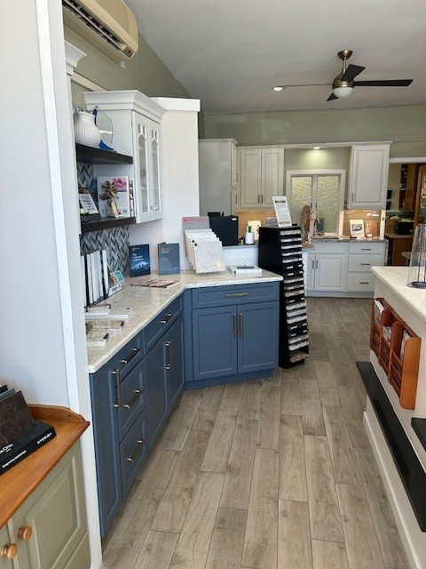

Latest Industry Trends
With KBIS 2026 in the books, this year set some records from the 117,000 industry professionals to 2,250 exhibitors. There were over 50 educational sessions and this year’s show was held in Orlando. Some of the key themes and takeaways included borderless design and functionality, vibrant color palettes, sustainable smart technology, innovative products and advanced, space-saving kitchen appliances.

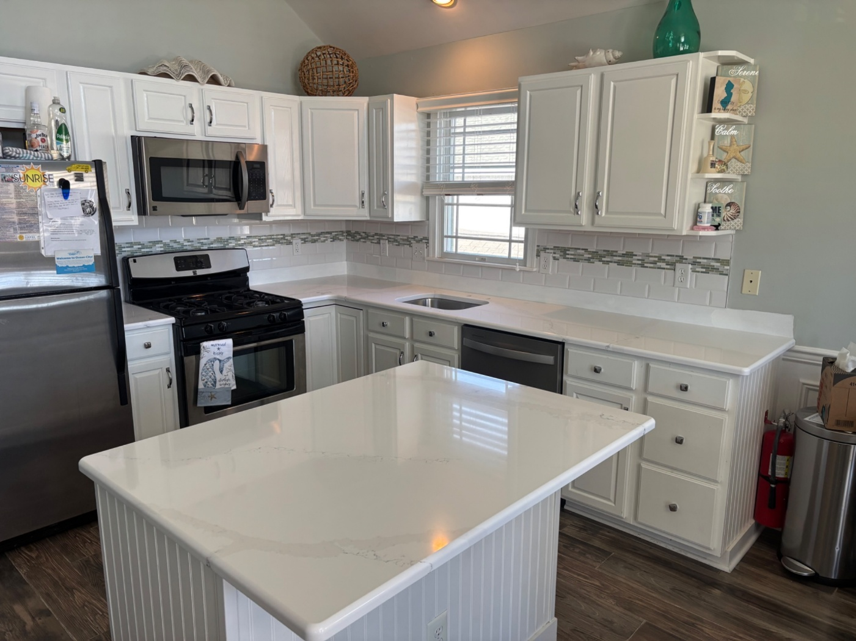

Suggestions for Future Newsletters and Summary

As 2026 continues into the spring season, there will be more renovations and construction projects that we will be involved in. If you have a client or exciting kitchen that you would like to do a product spotlight on in a future edition, on social media, or our website, please reach out to me so we can get some pictures and copy to publish to highlight this. If there is anything that you suggest for our next newsletter, please reach out to me.

Matt Zuccarello

Stone Crafters

