2025 QUARTERLY REPORT
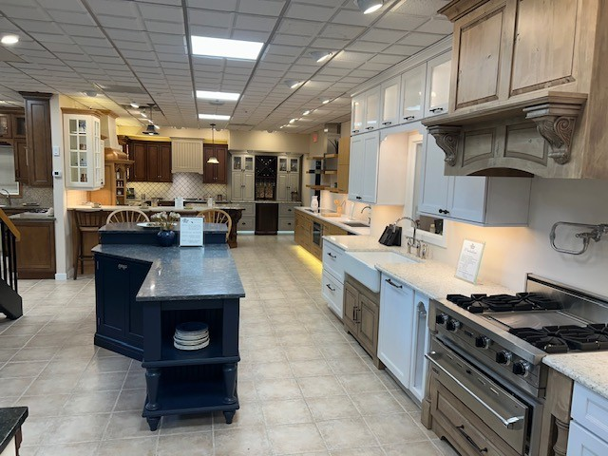

September 22, 2025

STONE CRAFTERS LLC
Authored by: Matt Zuccarello

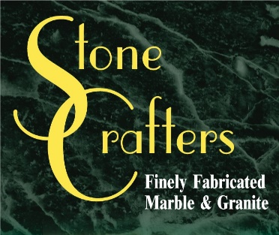

Company Spotlight – The Cabinet Shop
Owners: Joe and Kathi DiCicco, Marcie Russell-Office Manager, Tedd Russell-Designer, Rick Russell-Designer, Corey Ralston-Designer
Background: Family-owned business since 1991, moved from Rio Grande Airport showroom to their current location in Cape May Court House in 2001
Highlights: Best of House & Home Magazine every year since 2018 and featured in Cape May Magazine in Summer 2025 edition
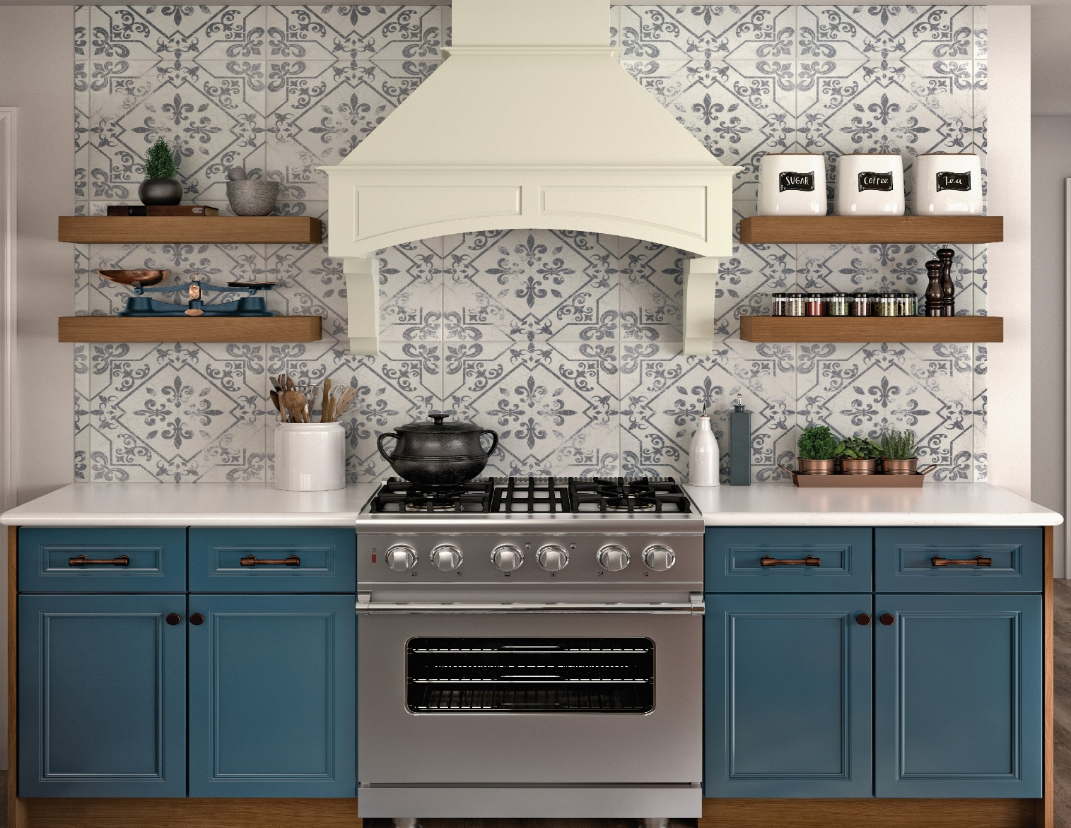
Ron Cyphers is the owner of C & C Cabinetry South, who moved their operation in 2007 to Forked River. They have been family owned since 1988 and transitioned from multi-family housing projects to semi-custom, single-family homes and renovations. They only focus and primarily sell American made cabinetry. They have been working with Stone Crafters as their main fabricator since 2019. Jake Morgan has been with the company since 2018 as their kitchen designer and Sales Consultant. He came right out of high school and has worked with them ever since. He enjoys and handles all aspects of the business as Ron’s right- hand man. They continue to focus and expand their business in Ocean County. Jack Cyphers, Ron’s brother, is one of the Sales Consultants that primarily works the showroom.
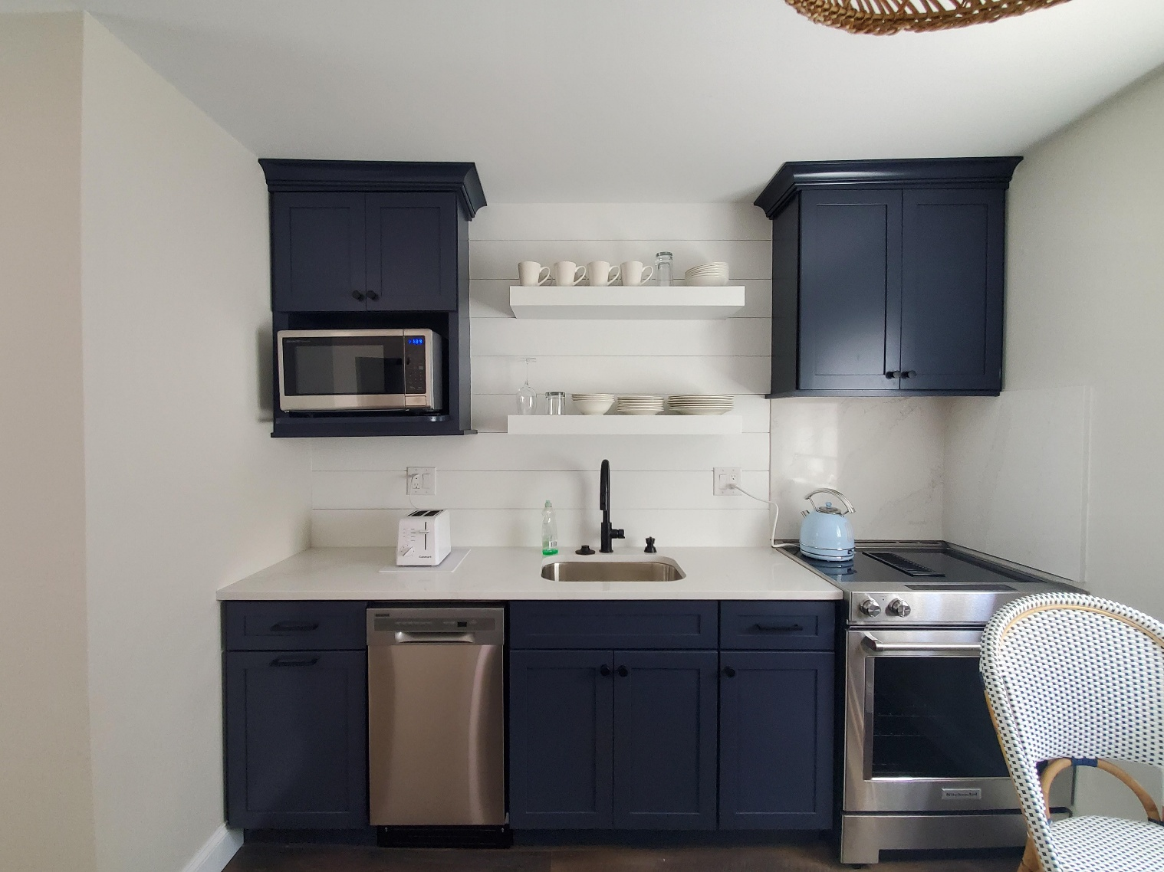

Latest Industry Trends
The latest kitchen and bathroom trends emphasize a combination of functionality, sustainability, and personalized luxury, with a growing focus on wellness and technology integration. Deep blues and greens seem to be making a statement, when it comes cabinetry in the kitchen. Bathrooms are becoming more spa-like, with the incorporation of heated floors, steam showers and natural materials.

Just to summarize, some of the kitchen trends include color and personality, combination islands, hidden pantries and panel-ready appliances, warm neutrals and greens/blues, natural materials, high-tech integration and eco-friendly features.

In regards to the bathroom trends, spa-like retreats, tactile surfaces, stone drenching, high-tech upgrades, color and texture, biophilic design, and antimicrobial finishes and bidets are leading the way.

Suggestions for Future Newsletters and Summary

As 2025 continues on and we get closer to the summer, there will be more renovations and construction projects that we will be involved in. If you have a client or exciting kitchen that you would like to do a product spotlight on in a future edition, on social media, or our website, please reach out to me so we can get some pictures and copy to publish to highlight this. If there is anything that you suggest for our next newsletter, please reach out to me.

Matt Zuccarello

Stone Crafters

