2026 QUARTERLY REPORT
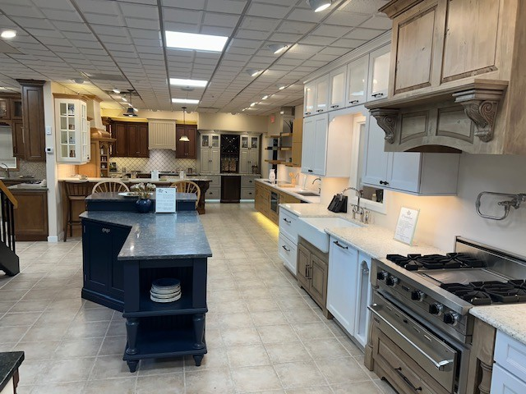

December 3, 2025

STONE CRAFTERS LLC
Authored by: Matt Zuccarello

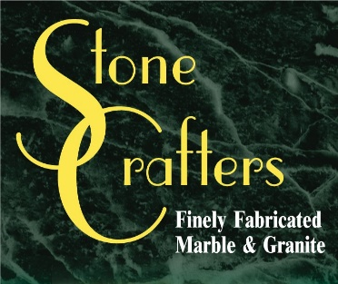

Company Spotlight – The Cabinet Shop
Owners: Joe and Kathi DiCicco, Marcie Russell-Office Manager, Tedd Russell-Designer, Rick Russell-Designer, Corey Ralston-Designer
Background: Family-owned business since 1991, moved from Rio Grande Airport showroom to their current location in Cape May Court House in 2001
Highlights: Best of House & Home Magazine every year since 2018 and featured in Cape May Magazine in Summer 2025 edition
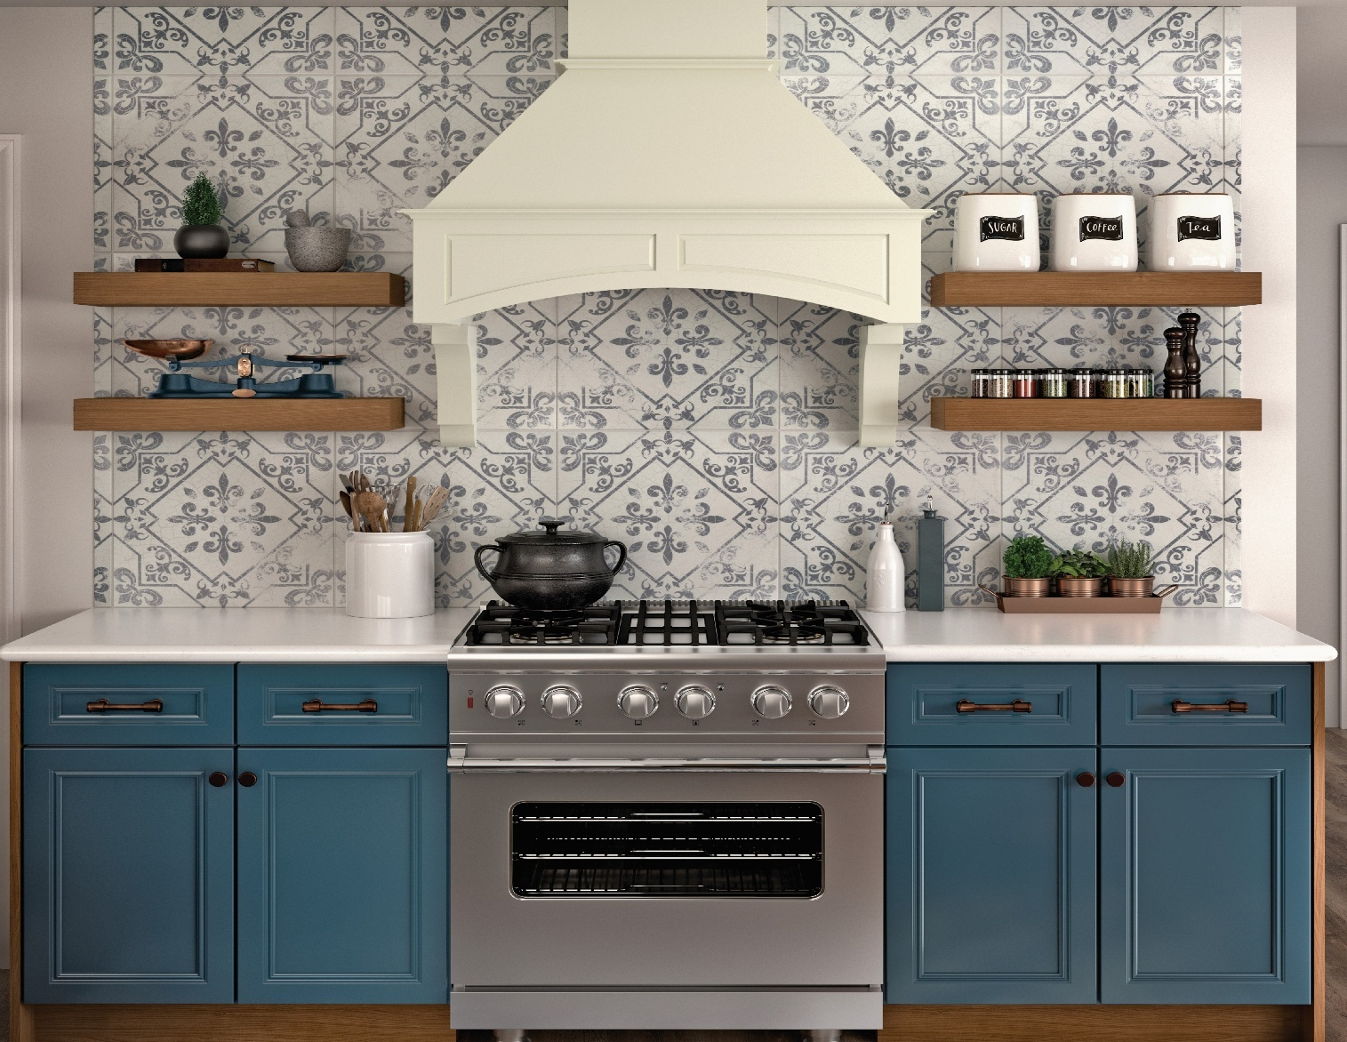
When Joe and Kathi DiCicco started this venture back in 1991, they never imagined all the changes the kitchen and bath industry has seen over the past 34 years. From cabinet colors and trends, to quartz and quartzite becoming the more popular choice over granite for countertops, and moving from a small showroom at the Rio Grande Airport to a nice spacious area in Cape May Court House, things have progressed nicely. After speaking with their Office Manager Marcie Russell and their design team that consists of Tedd and Rick Russell, along with Corey Ralston, they all bring different insights into the ever-changing landscape of kitchen and bathroom design, and are the faces of this small, close-knit company. Their focus has been serving homeowners in the Cape May and surrounding areas in renovating their homes and kitchen countertops to modernize them into the show-stopping centerpieces to host holidays and other family functions.
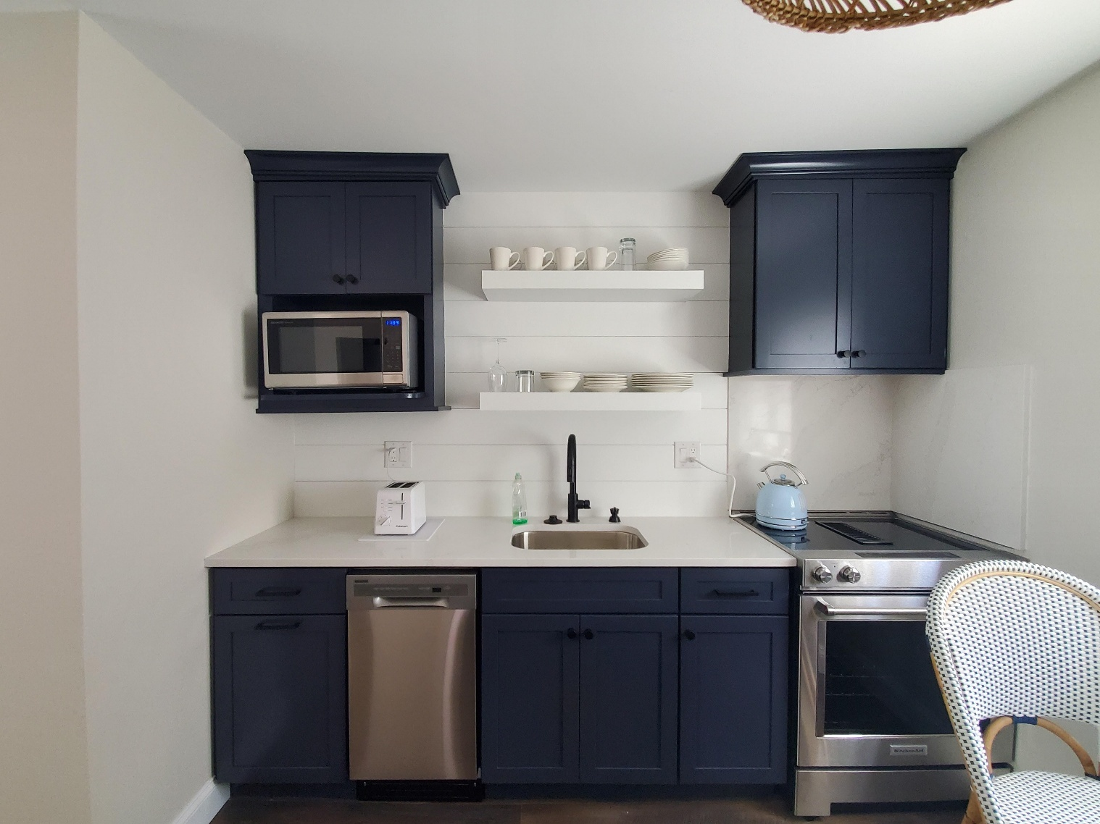

Latest Industry Trends
The latest kitchen and bathroom trends focus on creating warm personal, and sustainable spaces through warm minimalism, biophilic design, bold colors, especially earth tones, and mixed metal finishes. Smart technology integration, spa-inspired bathrooms and multifunctional designs are also popular, along with statement lighting and durable, eco-friendly materials like natural stone and reclaimed wood.

In regards to the bathroom trends, spa-inspired retreats, bold color palettes, luxurious natural stones, and soft metal finishes continue to lead the way in 2025.

Suggestions for Future Newsletters and Summary

As 2025 closes and we get closer to the holiday season, there will be more renovations and construction projects that we will be involved in. If you have a client or exciting kitchen that you would like to do a product spotlight on in a future edition, on social media, or our website, please reach out to me so we can get some pictures and copy to publish to highlight this. If there is anything that you suggest for our next newsletter, please reach out to me.

Matt Zuccarello

Stone Crafters

