2026 QUARTERLY REPORT
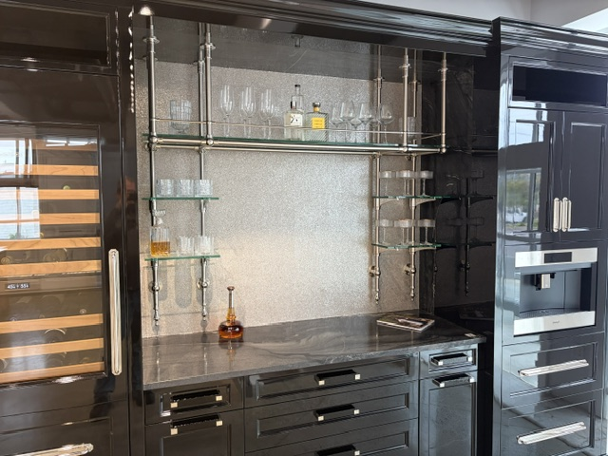

September 30, 2026

STONE CRAFTERS LLC
Authored by: Matt Zuccarello

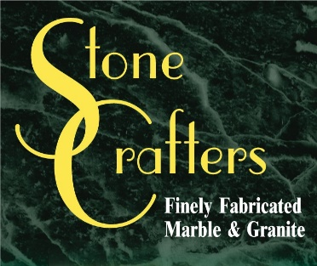

Company Spotlight – Colmar Kitchen and Bath
Owner: Tom Collins
Designers: Danielle McDonald, James Logue, Elena Obelenus, Lily Ransom, Loris Halsa, Rachel Hale, and Tim Kriebel
Background: Family-owned business for 22 years originally located in Margate, expanded to Avalon and Cape May two additional showrooms. Has 20 employees in the kitchen and bath market, including 7 designers and 7 assistants. He has a wife and two children and live in Linwood. He went to college at Villanova University and majored in Finance
Hobbies: Tom enjoys spending time with his kids
Highlights: Designers featured in many publications including House Beautiful and Architectural Digest, NKBA innovative showroom award for Margate in 2015

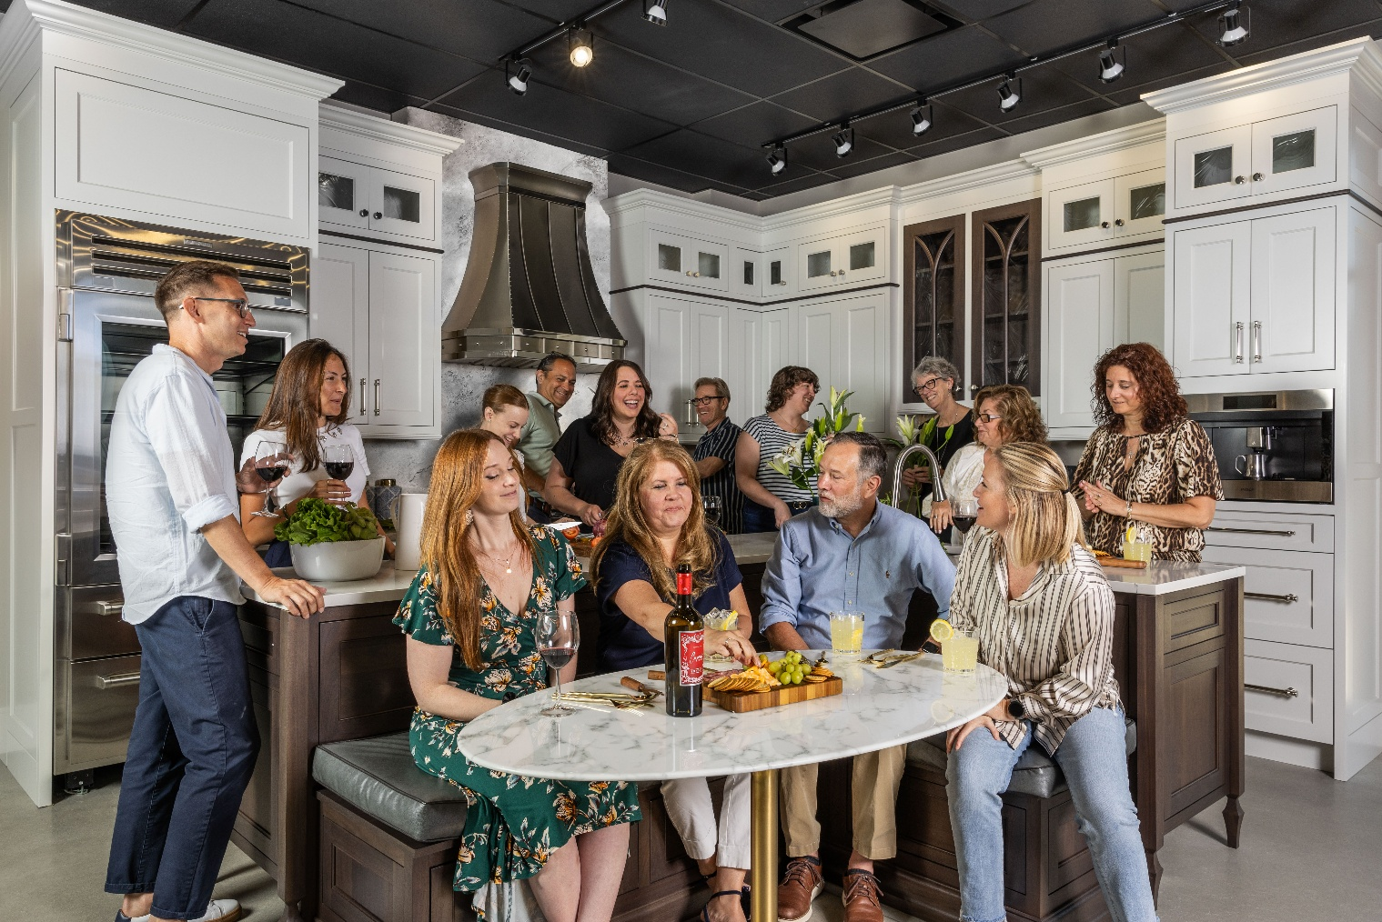
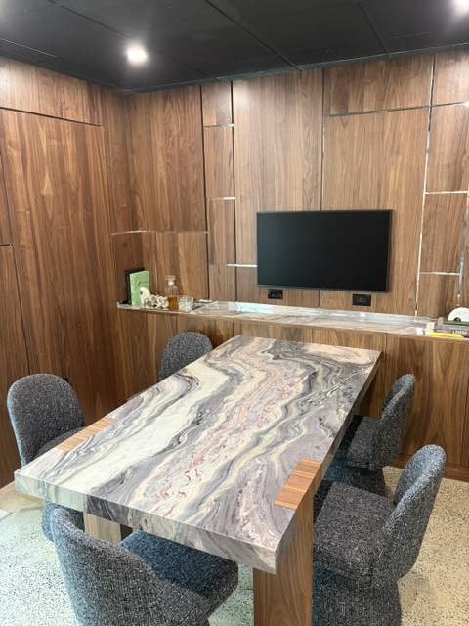
Founded by Tom Collins more than 22 years ago, Colmar Kitchen Studio has grown into a team of 20 serving homeowners throughout the southern New Jersey shore. What began in Margate has expanded to showrooms in Avalon and North Cape May, with the Avalon showroom recently moving to a new location after eight years.
Colmar’s designers and support team work together to create kitchens and baths tailored to each home and the people who live there. Their projects bring together cabinetry, and countertops of carefully selected materials, including quartz, quartzite, and granite. The team’s work has been featured in House Beautiful and Architectural Digest, and Colmar’s Margate showroom received an NKBA award for Innovative Showroom Design in 2015.
The design team includes Danielle McDonald, Tim Kriebel, Rachel Hale, James Logue, Elena Obelenus, Lily Ransom, and Loris Halasa. Together with Colmar’s assistants and the rest of the team, they continue to bring creative, practical ideas to homes across the shore.
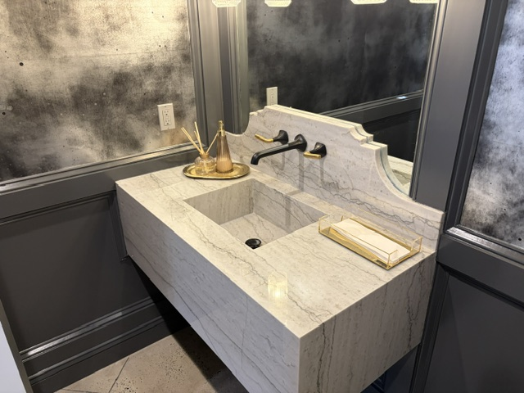

Latest Industry Trends
With 2026 approaching the holiday season, this year’s trends continue to focus on textured surfaces and statement countertops including quartzite, marble, and dramatic veined, red-toned stones are featured heavily for countertops and backsplashes. Furniture-styled vanities and softer , grounded traditional styles continued to lead the way when it comes to bathrooms trends this year.

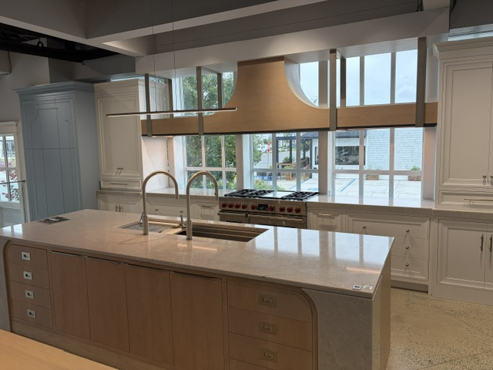

Suggestions for Future Newsletters and Summary

As 2026 continues into the spring season, there will be more renovations and construction projects that we will be involved in. If you have a client or exciting kitchen that you would like to do a product spotlight on in a future edition, on social media, or our website, please reach out to me so we can get some pictures and copy to publish to highlight this. If there is anything that you suggest for our next newsletter, please reach out to me.

Matt Zuccarello

Stone Crafters

