2024 QUARTERLY REPORT
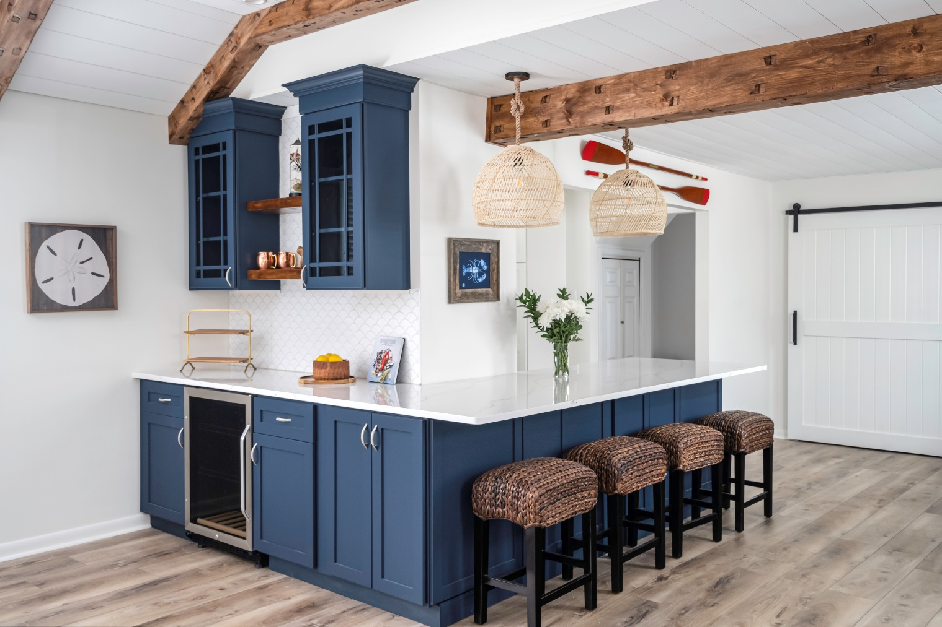

April 24, 2024

STONE CRAFTERS LLC
Authored by: Matt Zuccarello

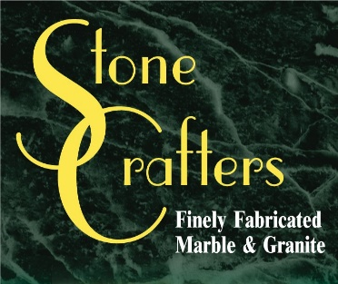

What’s happening so far in 2024?

News from the field

With KBIS in our rearview mirror for 2024, here were some of the key trends found from this years’ event.

KBIS celebrated their 60th anniversary this year and the show was as dynamic as ever. Even though smart appliances aren’t a new trend, KBIS featured the continual progression of connectedness and intuitiveness that these devices offer. From induction cooking to colorful appliances this show had a lot to offer, including record breaking numbers from exhibitors to attendees.

On the cabinet home front, sage green seemed to be the latest trend that ruled the showroom floor. Paired with wood and brass accents, the combination seemed to work, ideal for busy kitchens that need a dose of serenity, according to Kitchen Design NYC. Beyond the standard cabinets, brands got into developing creative built-ins, for access and organization. The new countertop offerings from MSI, Calacatta Miraggio Seaglass and Cambria, Inverness Bristol Bay would go great with these hot new cabinet colors.

There is plenty more to expand upon from the show and you can check out many different recaps online by searching 2024 KBIS, summary or trends. Jason McGraw, Group Vice-President, Emerald Expositions stated that the number of exhibitors at KBIS 2024 was the largest number of exhibitors the trade show had seen in its 60 years in the industry.

“This year, we had over 260 new exhibitors at KBIS, a 40% increase compared to last year, and over 117,000 registered visitors showed up to Design & Construction Week to see the best the industry has to offer.”

Company Spotlight – Cindy Kelly Kitchen Design

Background: 25 years in the Kitchen and Bath industry
College: Graduated with a degree in Interior Architecture from Arcadia University in PA
Resides in Lacey Twp, NJ
Hobbies include soaking in the sun at the beach and hiking
Business: Woman owned business for 12 years
Highlights: 2019 Crystal Design Award
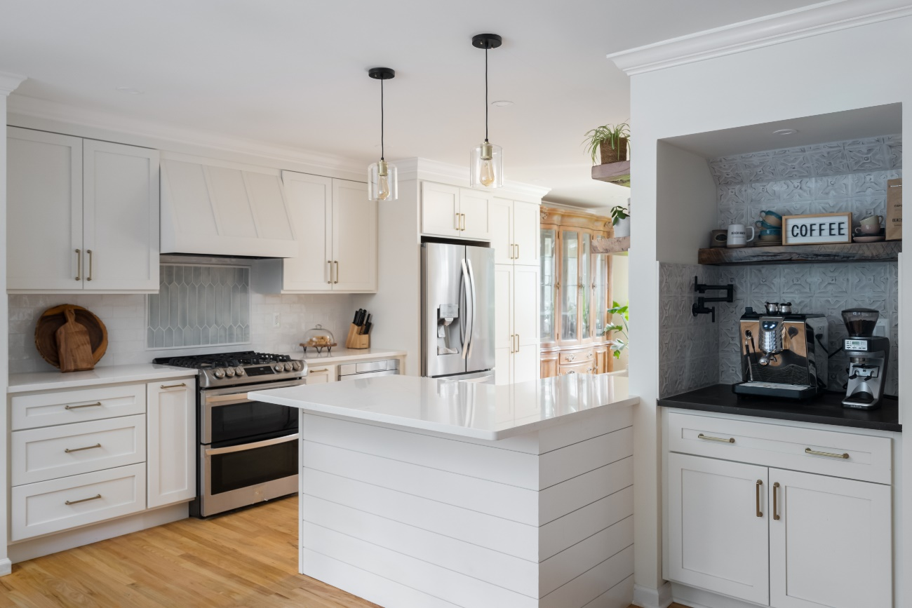

Cindy has been in the K & B industry for over 25 years now and has some done some beautiful home inspirations mainly on Long Beach Island in NJ and the surrounding area. She has been using Stone Crafters for her fabrication of her kitchen countertops for 20 years with various stunning designs and selections including Cambria, Silestone, MSI and others. The pictures in this newsletter speak for themselves. She continues to build her business in LBI and is located in Beach Haven. If you are ever on the island, stop in for a visit to see her beautiful showroom.

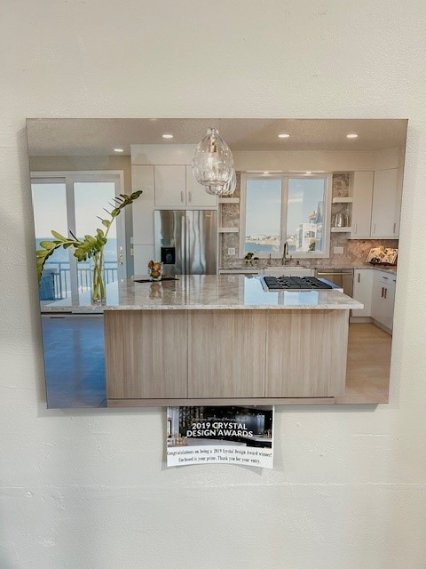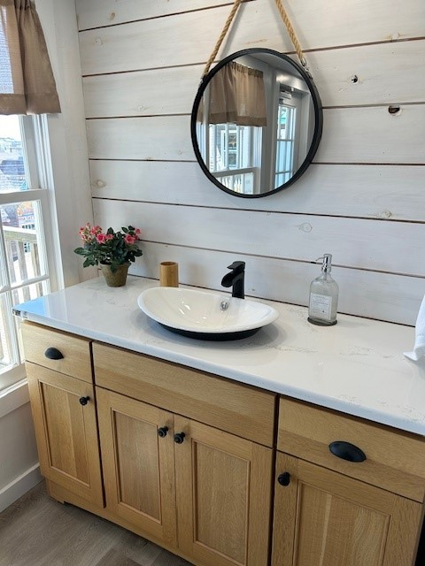

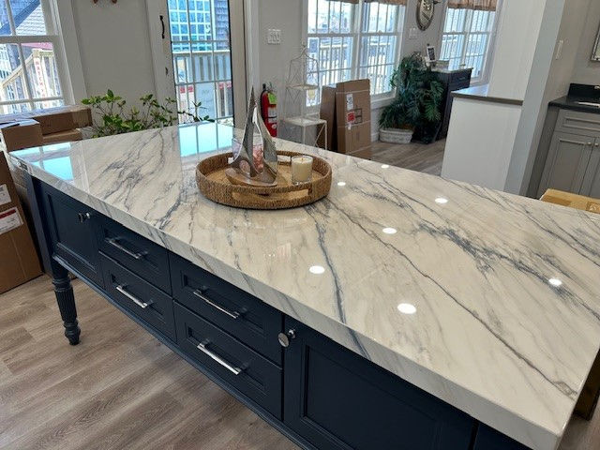
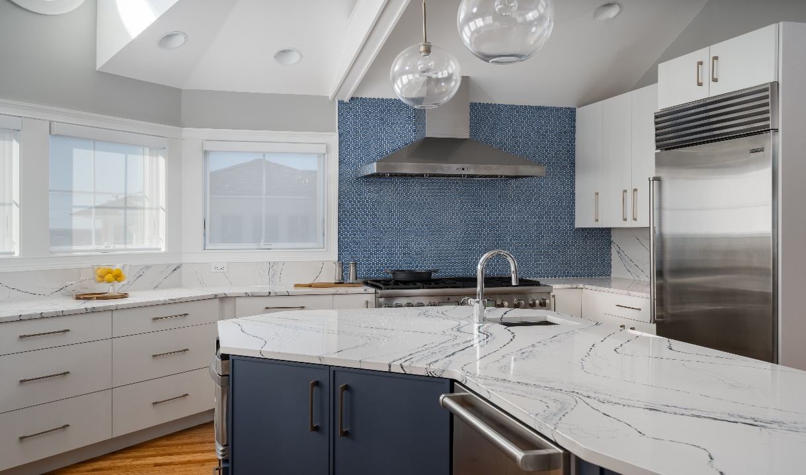

Suggestions for Future Newsletters and Summary

As 2024 continues on, there will be new renovations and construction projects that we will be involved in. If you have a client or exciting kitchen that you would like to do a product spotlight on in a future edition, on social media, or our website, please reach out to me so we can get some pictures and copy to publish to highlight this. If there is anything that you would like for us to put in our next newsletter, please reach out to me.

Happy designing and remodeling!!

Matt Zuccarello

Stone Crafters

