2024 QUARTERLY REPORT
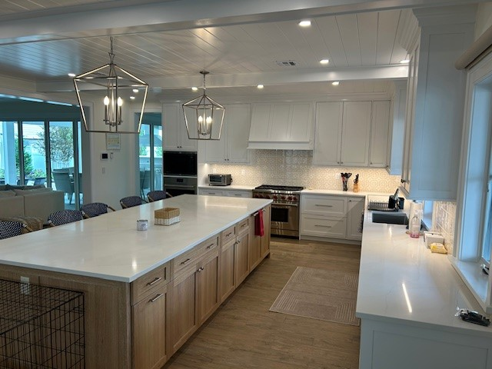

July 26, 2024

STONE CRAFTERS LLC
Authored by: Matt Zuccarello

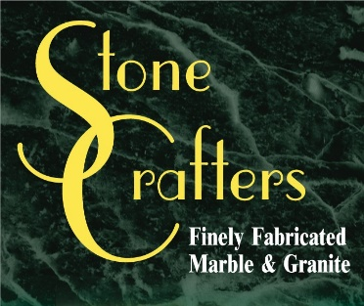

Company Spotlight – Sharpe Construction Design

Background: 30 years in business building mainly new houses
College: Graduated with a Bachelor’s Degree in Interior Architecture and Furniture Design from University of Bridgeport in CT
Hobbies include walking and yoga
Highlights: One of their houses featured in Versatex Building Products catalog
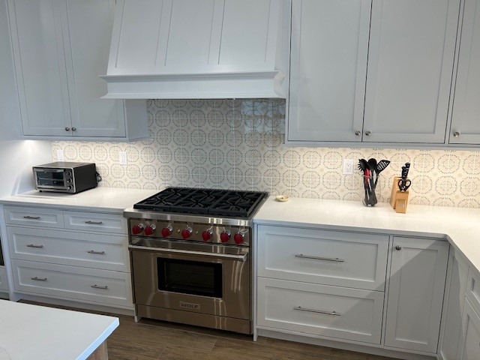
Christine Hedley is the Interior Architect and Project Manager for Owner, Bob Sharpe. She has been working for 7 years now with Stonecrafters in her current role and 21 years overall with us in previous companies. They mainly do new builds with a few renovation projects primarily on Long Beach Island, Manahawkin, Waretown, and Barnegat. They rebuilt many homes on Long Beach Island after Hurricane Sandy and other nasty storms that destroyed homes on the Jersey shore. The pictures in this newsletter speak for themselves. They were selected by the homeowners and include various designs from MSI, Hanstone, Cambria, and Caesarstone. The centerpiece features MSI’s Calacatta Abezzo, which is our most popular selection in our stock quartz program. This house is located in Beach Haven Park.

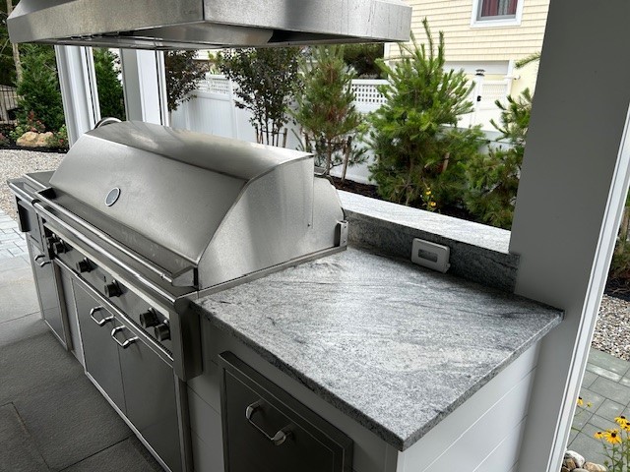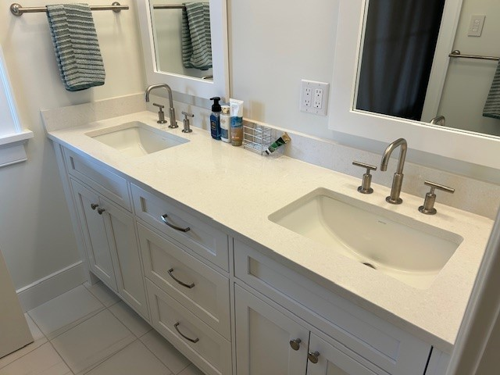

Latest Industry Trends

News from the field

Some of the latest trends when it comes to quartz countertops in 2024 include nature-inspired aesthetics which include Calacatta quartz, Soapstone quartz and woodgrain quartz at the top of the list. Bold and dramatic styles continue to be trending in the industry with homeowners choosing large-scale veining, deep, rich colors, and high contrast to maximize the impact of these bold colors.

Charcoal gray, navy blue, and emerald green lead the way when it comes to those choosing bold and dramatic colors.

Some of the benefits of the ones who have a flair for the dramatic include unique aesthetics, versatility and durability of the quartz chosen. Before making a decision on this trend, one should consider lighting, countertop size and overall design style.

One other thing trending in the industry is matte finish. Offering a more subtle and sophisticated look, this continues to surge in the design world. Being less prone to showing fingerprints and water spots, they have become a practical choice for busy households.

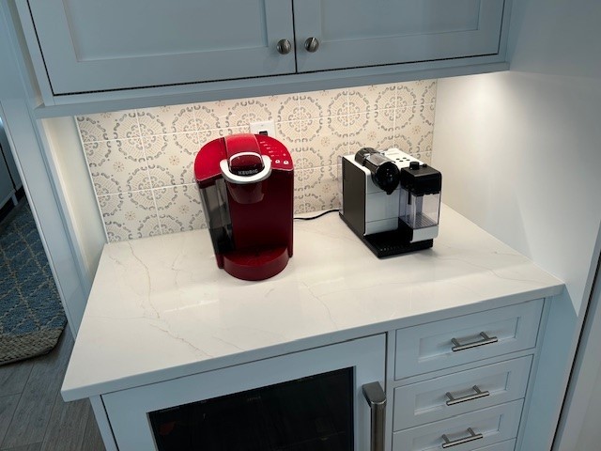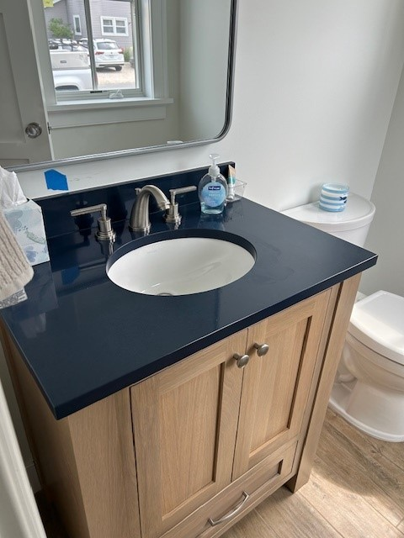

Suggestions for Future Newsletters and Summary

As 2024 continues on, there will be new renovations and construction projects that we will be involved in. If you have a client or exciting kitchen that you would like to do a product spotlight on in a future edition, on social media, or our website, please reach out to me so we can get some pictures and copy to publish to highlight this. If there is anything that you would like for us to put in our next newsletter, please reach out to me.

Happy designing and remodeling!!

Matt Zuccarello

Stone Crafters

